**Lab Practice 2 – Database Systems**

**Roll No: 2k20/ITE/73 Name: Mubashir Ali**

**Practice Question 1**

Create a query to display the last name and salary of employees earning more than 12,000.

**See output below**

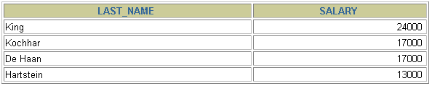

Answer:

SELECT last_name, salary

FROM employees

WHERE salary > 12000;

_______________________________________________________________________________

**Practice Question 2**

**Create a query to display the employee last name and department number for employee number  
 176.**

**See output below**



**Answer:**

**SELECT last_name, department_id**

**FROM employees**

**WHERE employee_id = 176;**

**___________________________________________________________________________**

**Practice Question 3**

Display the last name and salary for all employees whose salary is not in the range of 5,000 and 12,000.

**See output below**

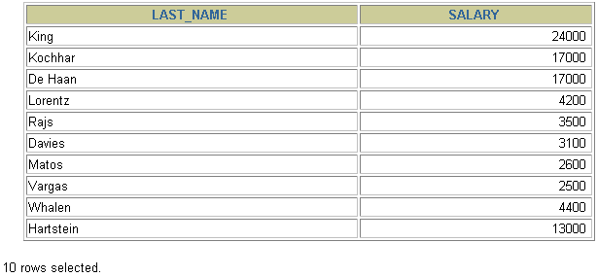

**Answer:**

**SELECT last_name, salary**

**FROM employees**

**WHERE salary NOT BETWEEN 5000 AND 12000;**

**____________________________________________________________________________**

**Practice Question 4**

Display the employee last name, job ID, and start date of employees hired between 02-2-2002, and 02-02-2005.

**See output below**

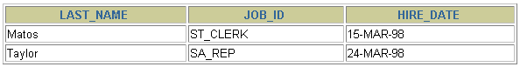

Answer:

SELECT last_name, job_id, hire_date

FROM employees

WHERE hire_date BETWEEN '02-02-2002' AND '02-02-2005';

_____________________________________________________________________________

**Practice Question 5**

Display the last name and department number of all employees in departments 20 and 50 in alphabetical order by name.

**See output below**

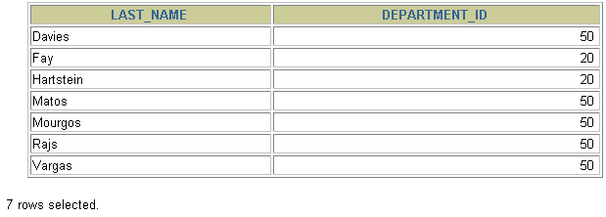

Answer:

SELECT last_name,department_id

FROM employees

WHERE department_id IN (20, 50)

Order by last_name;

______________________________________________________________________________

**Practice Question 6**

List the last name and salary of employees who earn between 5,000 and 12,000, and are in department 20 or 50.

**See output below**

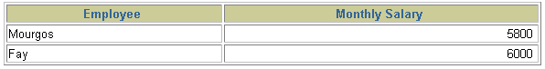

Answer:

______________________________________________________________________________

**Practice Question 7**

Display the last name and hire date of every employee who was hired in 2002.

**See output below**

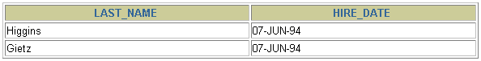

Answer:

SELECT last_name, hire_date

FROM employees

WHERE hire_date LIKE '%94';

______________________________________________________________________________

**Practice Question 8**

Display the last name and job title of all employees who do not have a manager.

**See output below**



Answer:

SELECT last_name, job_id

FROM employees

WHERE manager_id IS NULL;

______________________________________________________________________________

**Practice Question 9**

Display the last name, salary and commission of all employees who are earning commission

**See output below**

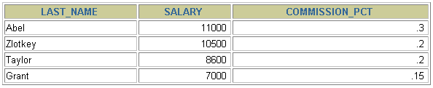

Answer:

SELECT last_name, salary, commission_pct

FROM employees

WHERE commission_pct IS NOT NULL

ORDER BY salary DESC, commission_pct DESC;

______________________________________________________________________________

**Practice Question 10**

Display the last names of all employees where the third letter of the name is “*a”.*

**See output below**

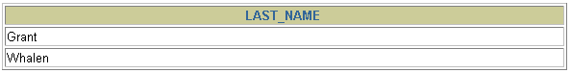

Answer:

SELECT last_name

FROM employees

WHERE last_name LIKE '__a%';

______________________________________________________________________________

**Practice Question 11**

Display the last name of all employees who have letter “*a”* and “*e”* in their last name.

**See output below**

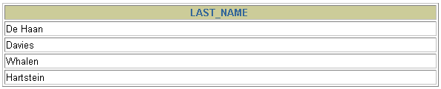

Answer:

SELECT last_name

FROM employees

WHERE last_name LIKE '%a%'

AND last_name LIKE '%e%';

______________________________________________________________________________